Content

1. Introduction
2. ADVANTAGES AND OBJECTIVES
3. ER Diagram:
4. Table Normalization:
5. Schema Diagram
6. Description of Table
7. Insert values on Tables
8. query of this Hotel Management System
9. Conclusion
10. Acknowledgements

Introduction

This project is mainly made for management a hotel. In this project hotel management managers can maintain the records of customers and rooms. The hotel rooms have different categories. So there charges and records will be maintained accordingly. This project helps to maintain all the record of the customer who comes in to the hotel and leaves the hotel. This project will indeed help the hotel management and the staff members to manage and steer the hotel's functionality and transactions to realize its maximum potential in addition to its competence in the hotel business field. The system was carefully designed to ensure maximum efficiency of the system at the hotel. The main objective from this project is build and development system to manage all hotel activities.

ADVANTAGES AND OBJECTIVES

The main aim of the entire activity is to automatic the process of day to day activities of hotel like room activities, entering a new customer, assign a room according to customers demand,releasing the room and finally compute the bill etc. This project is designed to handle all the primary information. Booking is done through phone calls or through visit to the hotel booking office. The customer’s personal details such as Name, Age, Nationality, and Duration of stay, are input during booking in. For booking in, the management system generates the bills on daily basis and delivered to the customer in their rooms. Before checking out, the customer have to pay their bills if any, And the management system can easily handle it by calculating total bills. This project intends to introduce more user friendliness in the various activities such as record updating, maintenance, and searching.The searching of record has been made quite simple as all the details of the customer can be obtained by simply keying in the identification of that customer. The entire information has maintained in the database, authorization user can retrieve the necessary information which can be easily be accessible from the table. The main objective of the entire activity is to automate the process of day to day activities of hotel.

This project is useful for the authorities which keep track of all the users registered in a particular state. In the past the records and supposed to be manually handled for all activities. The manual handling of the record is time consuming and highly chance to error. To improve the performance of the hotel management system, the computerized system is to be undertaken. Now any one can easily manage the system. Whenever a new user submits their details the system is updated automatically.This record will be useful for other users instantly. The complete control of the project is under the authorities hand and the other member’s can see the records not to change the record. A hotel can easily manage the hotel management system by using this project.

ER Diagram:

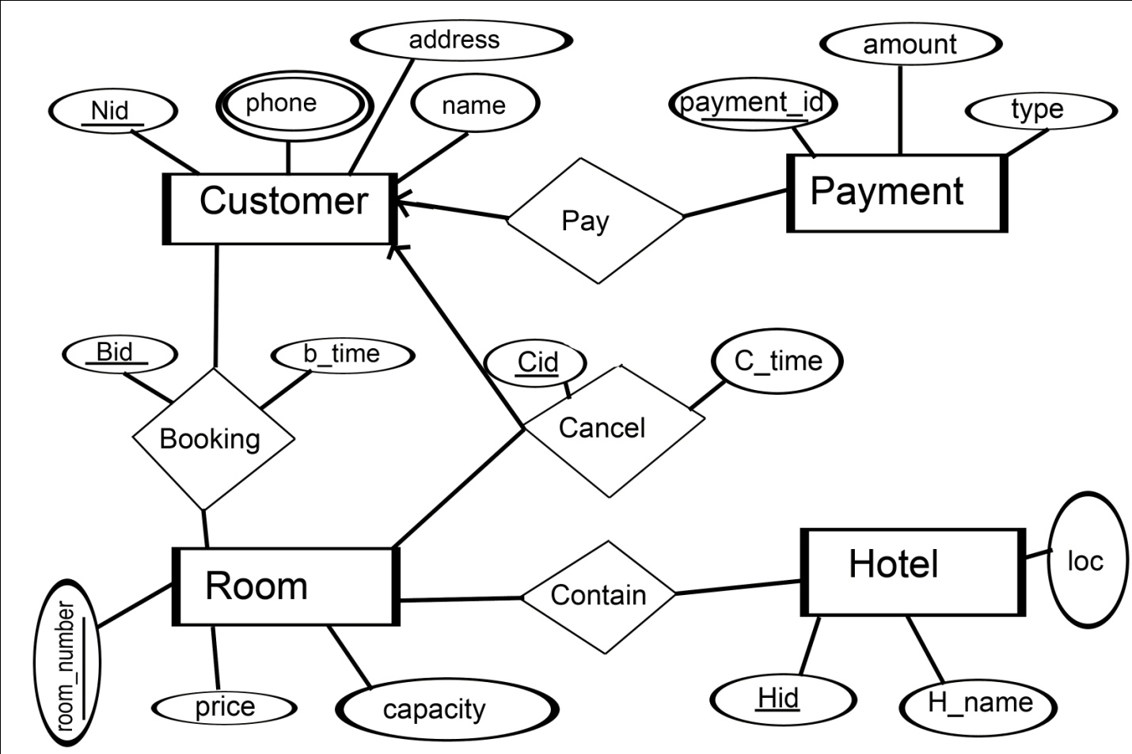

Table Normalization:

* Hotel _info (Hid,H_name,loc,Room_number,price,capacity)

**1NF:**

There are no multivalue attributes.

**2NF:**

Hotel (Hid,H_name,loc,Room_number)

Room (Room_number,price,capacity)

**3NF:**

Already in 3NF

* Cancel_info (Nid,phone,name,address,Cid,c_time,Room_number,price,

capacity)

**1NF:**

contact (Nid,phone)

Cancel_info (Nid,name,address,Cid,c_time,Room_number,price,capacity)

**2NF:**

contact (Nid,phone)

Room (Room_number,price,capacity)

Cancel (Nid,name,address,cid,c_time,Room_number)

**3NF:**

contact (Nid,phone)

Room (Room_number,price,capacity)

Customer (Nid,name,address,Cid)

Cancel (Cid,Room_number,c_time)

* Booking_info (Nid,phone,name,address,Bid,b_time,Room_number,price,

capacity)

**1NF:**

contact (Nid,phone)

Booking_info (Nid,name,address,Bid,b_time,,Room_number,price,capacity)

**2NF:**

contact (Nid,phone)

Room (Room_number,price,capacity)

Booking (Nid,name,address,Bid,b_time,Room_number)

**3NF:**

contact (Nid,phone)

Room (Room_number,price,capacity)

Customer (Nid,name,address,Bid)

Booking (Bid,Room_number,b_time)

* Pay_info (Nid,phone,name,address,payment_id,amount,type)

**1NF:**

Contact (Nid,phone)

Pay_info(Nid,name,address,payment_id,amount,type)

**2NF:**

Contact (Nid,phone)

Customer(Nid,name,address,payment_id)

Payment ( Payment_id,amount,type)

**3NF:**

Already in 3NF form

* After doing all normalization we got seven tables. Those are:

Customer(Nid,name,address,Bid,Cid,Payment_id)

Contact(Nid,Phone)

Room(Room_number,Price,Capacity)

Booking(Bid,Room_number,b_time)

Cancel(Cid,Room_number,c_time)

Payment(payment_id,amount,type)

Hotel(Hid,H_name,loc)

Schema Diagram is giver below:

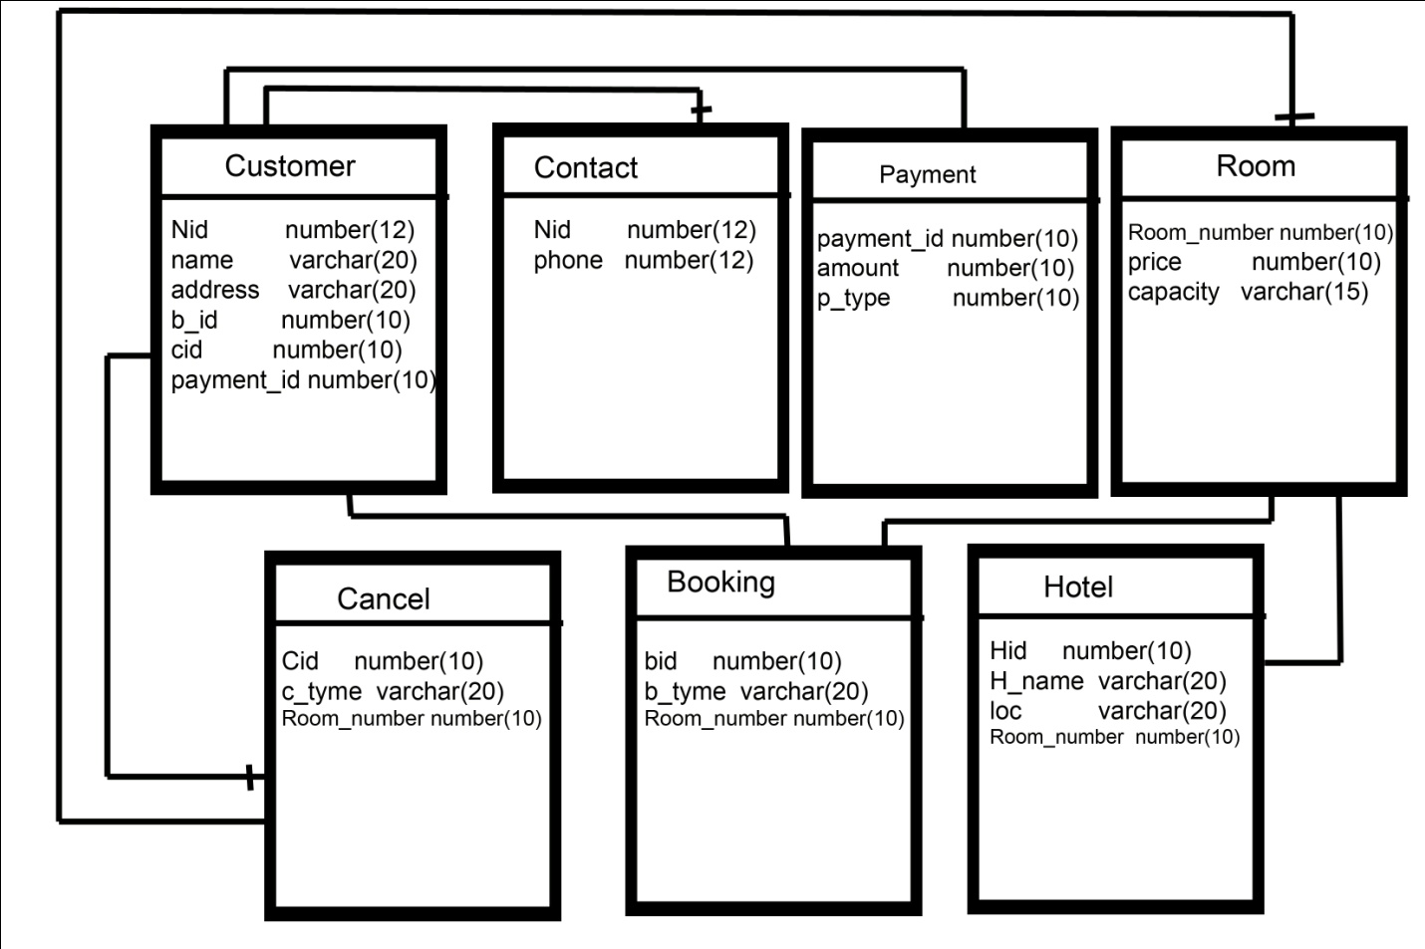

Description of Table:

Customer schema =(Nid,name,address,Bid,Cid,Payment_id)

Nid is National id of a customer.Here Nid is a primary key. its datatype is number

Name describe the customer name. its datatype is varchar

Here Address is customer adsress.its datatype is varchar

Bid is booking id. its datatype is number.here it is used as foreign key

cid is cancel id. its datatype is number.here it is used as foreign key

payment_id is. its datatype is number .here it is used as foreign key

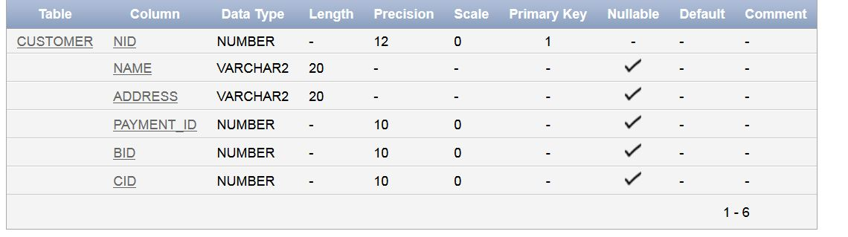

Contact schema =( (Nid,Phone)

Nid is National id of a customer.Here it is used as foreign key. its datatype is number

Phone number its datatype is number

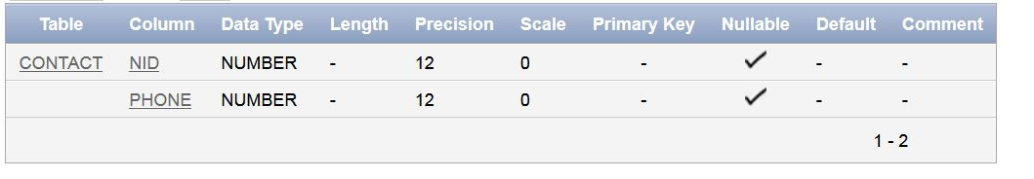

Room schema =( (Room_number,Price,Capacity)

Room_numer is unique so it is used as primary key. its datatype is number

The datatype of price is number

The datatype of capacity is varchar

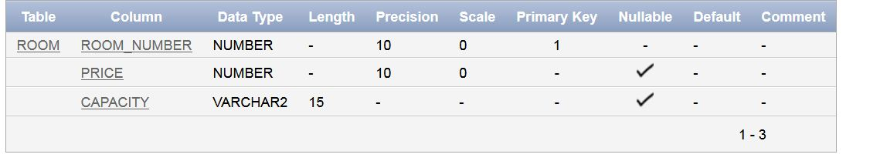

Booking schema =( (Bid,Room_number,b_time)

Bid is booking id.its datatype is number

Room_numer is used as foreign key. its datatype is number

B_time is booking time.its datatype is varchar

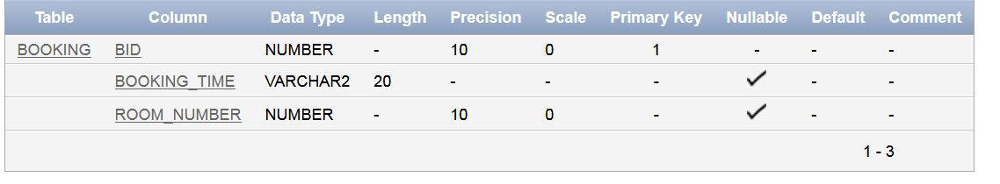

Cancel schema =( (Cid,Room_number,c_time)

cid is cancel id.its datatype is number

Room_numer is used as foreign key. its datatype is number

c_time is cancel time.its datatype is varchar

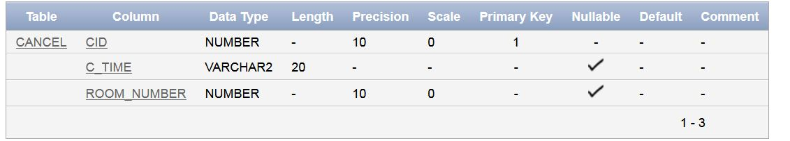

Payment schema =( (payment_id,amount,type)

Payment id is unique id ,so it is used as primary key .and its datatype is number

The datatype of amount is number

The datatype of type is varchar

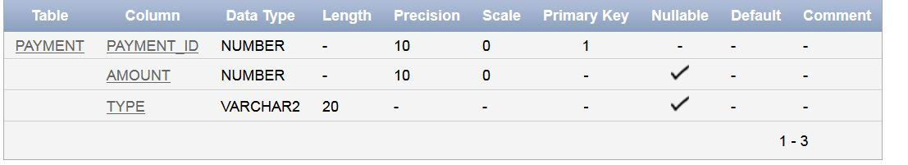

Hotel schema =( (Hid,H_name,loc)

Hid is primary key ,its datatype is number

H_name means hotel name ,its datatype is varchar

Loc means Location .its datatype is varchar

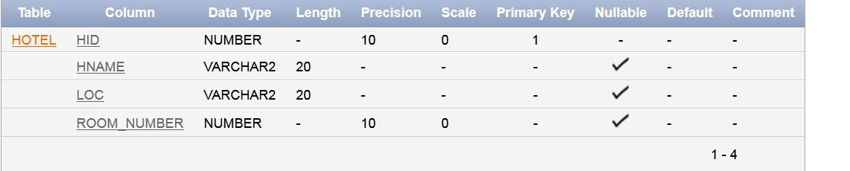

Insert values on Tables:

create table customer( nid number(12)primary key,name varchar(20),address varchar(20),payment_id number(10),

foreign key (payment_id) REFERENCES payment(payment_id),bid number(10),

foreign key(bid)references booking(bid),cid number(10),foreign key(cid) references cancel(cid))

insert into customer values(1011,'RONY','BADDA',1,1,1)

insert into customer values(1013,'RAJON','DHAKA',3,3,3)

insert into customer values(1012,'EMON','SYLHET',2,2,2)

insert into customer values(1014,'MAHEDI','COMILLA',4,4,4)

insert into customer values(1015,'MAHBUB','CHANDPUR',5,5,5)

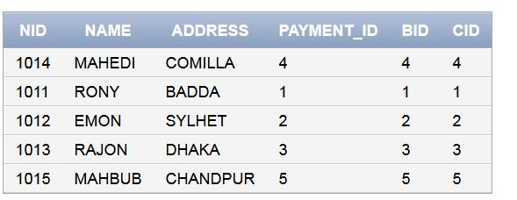

create table hotel(hid number(10)constraint h_pk primary key,hname varchar(20),loc varchar(20),

room_number number(10),constraint h_fk foreign key(room_number) references room(room_number))

insert into hotel values(1212,'A','chittagong',11)

insert into hotel values(1213,'A','sreemangal',12)

insert into hotel values(1214,'X','bandarban',13)

insert into hotel values(1215,'Y','khulna',14)

insert into hotel values(1216,'Z','dhaka',15)

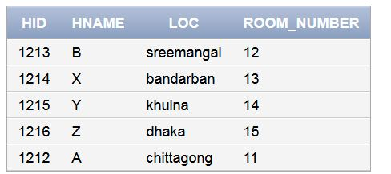

create table cancel(cid number(10)primary key,c_time varchar(20),

room_number number(10),foreign key(room_number)references room(room_number))

insert into cancel values(1,'1pm',14)

insert into cancel values(2,'4pm',11)

insert into cancel values(3,'8am',13)

insert into cancel values(4,'11am,12)

insert into cancel values(5,'12pm',15)

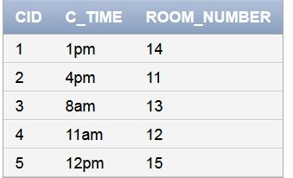

create table booking( bid number(10) primary key,booking_time varchar(20),

room_number number(10),foreign key(room_number) REFERENCES room(room_number))

insert into booking values(1,'10am',11)

insert into booking values(2,'8am',15)

insert into booking values(3,'4pm',13)

insert into booking values(4,'2pm',12)

insert into booking values(5,'11am',14)

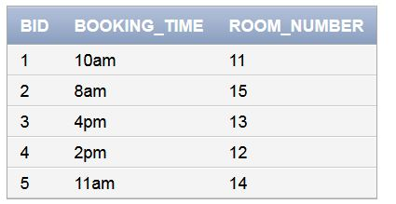

create table room(room_number number(10)primary key,price number(10),capacity varchar(15))

insert into room values (11,300,'3')

insert into room values (12,500,'2')

insert into room values (13,800,'2')

insert into room values (14,400,'3')

insert into room values (15,1000,'2')

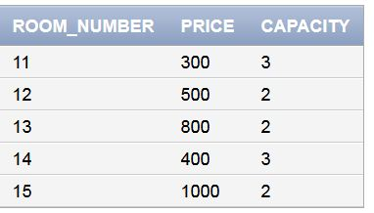

create table contact(nid number(12),phone number(12),foreign key(nid) references customer(nid))

insert into contact values(1011,01715682354)

insert into contact values(1012,01725365891)

insert into contact values(1013,01753220952)

insert into contact values(1014,01740236589)

insert into contact values(1015,01750226589)

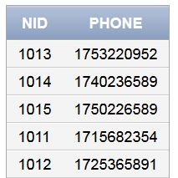

create table payment(payment_id number(10)primary key,amount number(10),type varchar(20))

insert into payment values(1,1000,'card')

insert into payment values(2,1600,'card')

insert into payment values(3,500,'cash')

insert into payment values(4,800,'bkash')

insert into payment values(5,400,'cash')

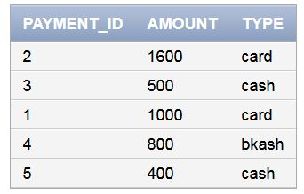

There are some query of this Hotel Management System:

1.How many Room has this hotel.

select count(room.room_number) from hotel,room

where hotel.room_number=room.room_number

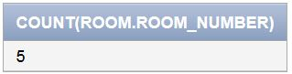

2.find out the room info where room capacity=3.

select * from room where capacity='3'

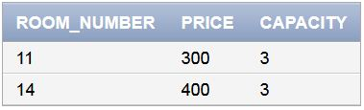

3.find out the phone number and name of a customer and phone number=1753220952

select name,phone from customer,contact

where customer.nid=contact.nid

and phone=1753220952

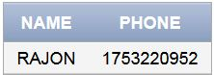

4.find out the customer name who had booked room number 11,22.

select name from customer,booking

where customer.bid=booking.bid

and room_number in(11,12)

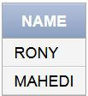

5.find out the customer who paid the maximum amount.

select customer.* from customer,payment

where customer.payment_id=payment.payment_id

and amount=(select max(amount) from payment)

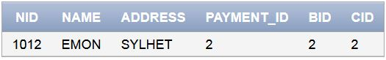

6.select the hotel name,loc,room number and price of room in 400-1000

select hname,loc,room.room_number,price from hotel,room

where hotel.room_number=room.room_number

and price between 400 and 1000

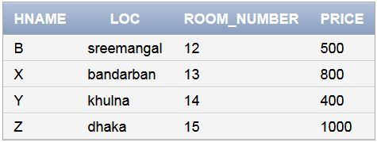

7.select the customer who booked room at 10 am

select name from customer,booking

where customer.bid=booking.bid

and booking_time='10am'

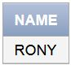

8.select the customer who cancel at 4pm

select name from customer,cancel

where customer.cid=cancel.cid

and c_time='4pm'

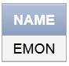

9.select customer name and payment info

select name,payment.* from customer,payment

where customer.payment_id=payment.payment_id

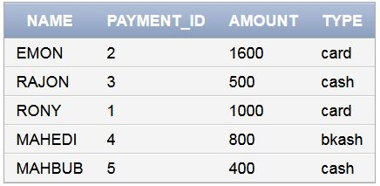

10.select the customer name with booking info.

select name,booking.* from customer,booking

where customer.bid=booking.bid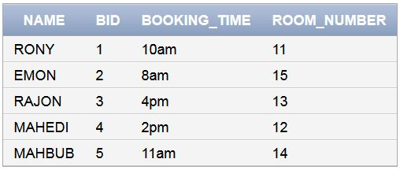

Conclusion

This project is designed to handle the requirements of hotel management system. For designing the system we have used flow diagrams. We hope this project is helpful for hotel managers.

Acknowledgements

The project teaches us the essential skills to handle various data. Its very easy to draw a diagram of any management system but its very hard to normalized the system. In this project we understand the database handling and query processing. This project helps us to manage various data in a simple way. Hopefully we can now manage many other management problems. In this project we learn who to manage a system by using system analysis and design techniques like data flow diagram is designing the system.